Town of Germantown Local Waterfront Revitalization Study

COMMUNITY OUTREACH PLAN
March 2, 2017

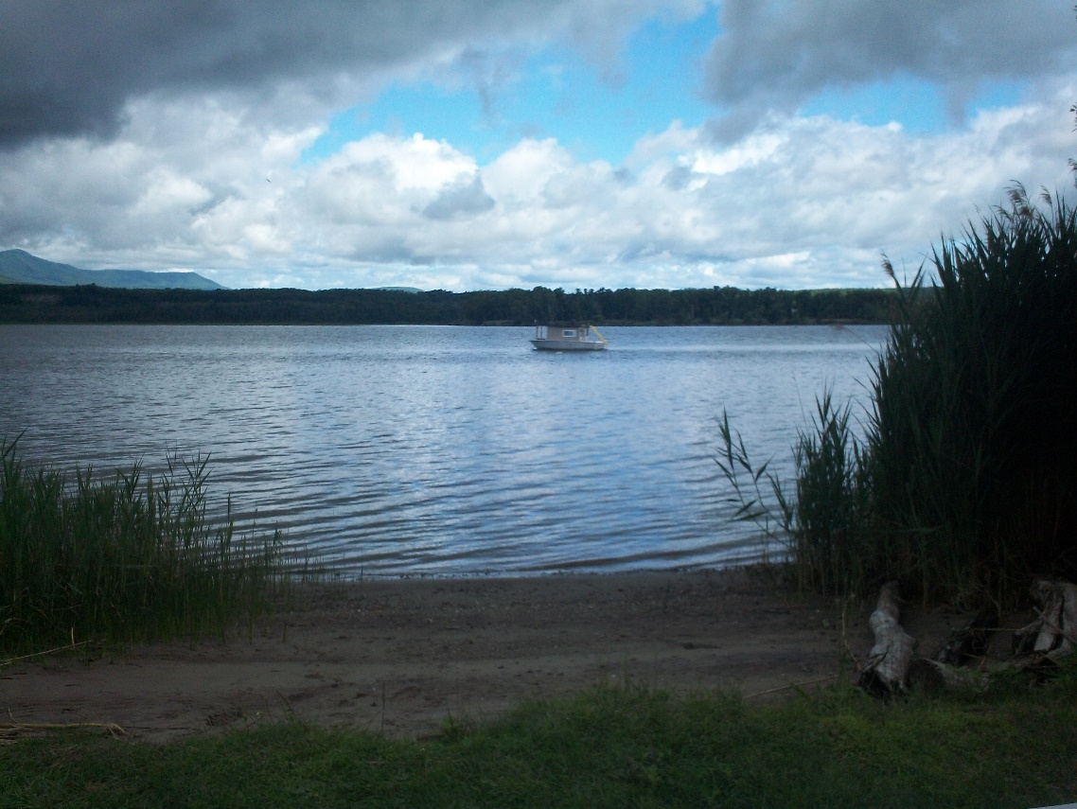

Contract # C1000681
Task 8

Prepared by: With Assistance from:
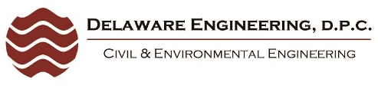
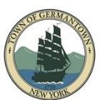
Town of Germantown
Local Waterfront Revitalization Study
Project Advisory Committee

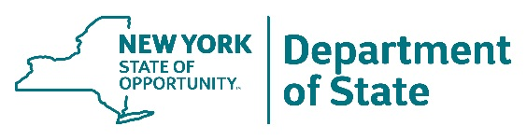
This document was prepared with funding provided by the New York State Department of State under Title 11 of the Environmental Protection Fund.

1.0 Introduction
Background
The Town of Germantown has received a matching grant from the New York State Department of State (NYSDOS) to develop a Local Waterfront Revitalization Study. The purpose of the Study is to improve public access and recreational use of the Hudson River and Roeliff Jansen Kill while protecting and preserving natural resources. The Study’s long range goals are to foster waterfront revitalization, sustainability and economic investment within the Town. The Study will assess existing waterfront access and recreational resources, identify issues and opportunities, develop conceptual plans for improvement projects and actions, and make recommendations for their implementation.

The Local Waterfront Revitalization Study will guide future development along the Hudson River and Roeliff Jansen Kill waterfronts and adjacent areas in the Town of Germantown. In addition, the Study will help advance future improvement projects by making the Town eligible to apply for implementation funding through the Consolidated Funding Application and other applicable grants and loans.

Project Team
The Town of Germantown has established a Project Advisory Committee (PAC) to guide the Study and has selected Delaware Engineering, D.P.C. to facilitate its development. The PAC is comprised of key individuals representing local community organizations who are invested in the Town’s waterfront and future. Note that the Town is also concurrently updating their Comprehensive Plan, therefore the PAC will coordinate with the Comprehensive Plan Committee to ensure that both plans are developed with consistent visions and goals.
Project Advisory Committee
Name | Affiliation, Roles and Responsibilities
Jen Crawford, EIT, BSI | Project Advisory Committee Chair, Treasurer of Roe-Jan Creek Boat Club  Staff Engineer at Crawford & Associates Engineering & Land Surveying, PC
Christina Bohnsack | Member of Roe-Jan Creek Boat Club, Board of Directors of GTel Teleconnections
Kaare Christian | Producer at Living in Digital Times, Founder of the Roe Jan Watershed Organization
William Foster | Senior Investigator Columbia County Sheriff’s Office, Avid Boater
Robert Nedwick | President of Southern Columbia Little League, Treasurer of Southern Columbia Soccer League
Martin Overington | Annual River Sweep Organizer w/wife Kathy, Boy Scout Leader Troop 122, Germantown Library: Makerspace and Buildings/Grounds Committees, Germantown Park Program, Lead Researcher Specialist at RPI Lighting Research Center
William Shannon | Editor of HudsonRiverZeitgeist.com, member of Roe-Jan Creek Boat Club and Germantown Sportsmen’s Association
Donald Westmore | Secretary of The Friends of Clermont, President of Germantown Neighbors Association, Former Town of Germantown Councilman
Phil Williams | Member of Roe-Jan Creek Boat Club and Germantown Sportsmen’s Association, Former Town of Livingston Supervisor

2.0 Waterfront Revitalization Study Area
The Project Team has defined the Waterfront Revitalization Study Area, which is based on the NYS Coastal Area Boundary. The Study Area includes the area between the center of the Hudson River and State Route 9G, the Roeliff Jansen Kill along the northeastern Town border, all four municipal parks (Cheviot, Lasher, Palatine and Roe-Jan), and two Town-owned underwater parcels. It incorporates the Town’s Waterfront Scenic Overlay District as well as portions of two NYS Scenic Areas of Statewide Significance: the Catskill-Olana District and the Estates District.

Waterfront Revitalization Study Area
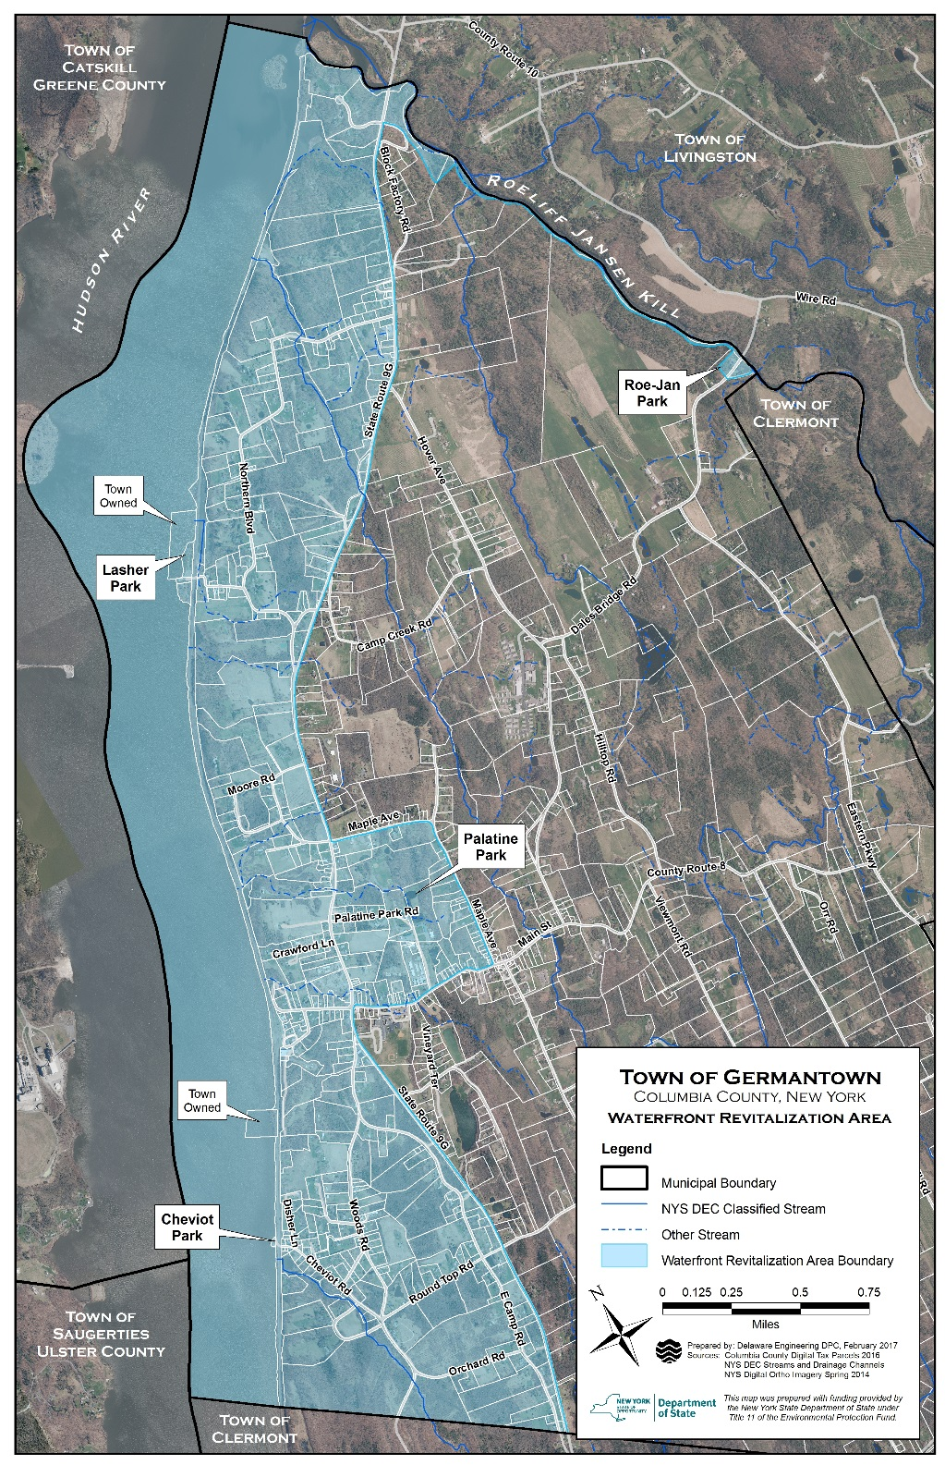

3.0 Community Participation
Public involvement and participation will be critical in developing the Local Waterfront Revitalization Study. The Community Outreach Plan is intended to describe the methods by which the public and key stakeholders will be informed of and engaged in the Study. Interested residents, property owners, public officials and agencies and other stakeholders will be encouraged to identify priority issues and areas of concern and help shape the recommendations and future actions.

A variety of community outreach and engagement activities will be used to inform the public and gather input to guide the Study including:

- Key Stakeholder Outreach
- Project Advisory Committee Meetings
- Community Visioning Workshops
- Digital Outreach
- Community Handouts

3.1 Key Stakeholder Outreach
The PAC has identified a preliminary list of public and private agencies and interest groups who will be contacted directly and encouraged to participate in the planning process. The purpose of engaging these groups is to ensure that there is a broad understanding and awareness of the waterfront revitalization study, identify common goals and priorities and solicit diverse input from all interested parties.

- Town of Germantown Boards & Committees: Planning Board, ZBA, Comprehensive Plan,
Parks and Recreation, Business and Economic Development, Community, Arts and Tourism
- Town of Germantown Departments:
Police, History, Highway, Maintenance
- NYSDEC – Hudson River Estuary Program
- NYSDOS – Office of Planning and Development
- NYSDOT – Region 8 Planning & Program Mgmt.
- Town of Livingston
- Town of Clermont
- City of Hudson
- Village of Tivoli
- Village of Catskill
- Town of Catskill
- Columbia Co. Planning/Ec. Development Dept.
- Columbia Co. Tourism Department
- Columbia Co. Soil & Water Conservation District
- Cornell Cooperative Extension
- Hudson River Valley Greenway
- Hudson River Watertrail Association
- Hudson Sloop Club
- Roe-Jan Creek Boat Club
- Germantown Sportsmen’s Association
- Boy Scouts
- Girl Scouts
- Roe Jan Navigators
- Friends of Clermont
- Scenic Hudson
- Columbia Land Conservancy
- Riverkeeper
- Roe-Jan Watershed Community
- Trout Unlimited
- Cary Institute of Ecosystem Studies
- Saw Kill Watershed Community
- Germantown Lions Club
- Germantown Garden Club
- Germantown Library
- Germantown Central School District
- Columbia-Greene Community College
- Bard College
- Bard Water Lab
- CSX
- Amtrak

3.2 Project Advisory Committee Meetings
The Project Advisory Committee is the primary group guiding the preparation of the Study. All PAC meetings are open to the public and the date, time and location will be posted on the calendar on the Town website. The regular monthly PAC meetings are tentatively scheduled to occur on the 4th Tuesday of the month at Town Hall, however meeting dates may need to be adjusted at times. A draft project schedule is included in Section 5 of this plan.

The Committee Chairperson, PAC members, and other attendees will strive to employ orderly procedures when conducting and participating in meetings. An agenda will be prepared and distributed prior to each meeting when necessary. Meeting notes will be taken and distributed to members via email. The PAC has also set up a FTP site to share information and serve as a central data repository. All materials discussed at the meetings will be posted on the FTP site for further review and reference by committee members.

3.3 Community Visioning Workshops
Three community visioning workshops will be held at key milestones in the Waterfront Revitalization Study process in order to inform and gather input from the public and other stakeholders. Each meeting will be publicized on the Town’s website and Facebook page, through notices in The Columbia Paper, by flyers at community gathering places and events, and through direct emails as appropriate. A written summary of each community workshop will be prepared and posted on the Town website.

It is anticipated that the Project Team will begin each workshop with a formal presentation followed by a question and answer period and small group break-out sessions. Project Team members will be available in each small group to facilitate the discussion and record public sentiment. Presentation Materials and Boards will be set up to make it easy for attendees to record their opinions on particular issues.

First Workshop: Inventory, Issues/Opportunities and Vision
At the first community visioning workshop the Project Team will present the Inventory and Analysis of existing conditions in the Study Area, the preliminary issues and opportunities identified, and will solicit public input. Workshop activities will be designed to help participants reveal how they use and value their waterfront resources, and the varied relationships between the waterfront and the municipality. Participants will be encouraged to identify important issues and opportunities, discuss what they would like to change if they could, and articulate a vision for the future.

The Project Team will prepare an Initial Issues, Opportunities, and Vision Report, which is based upon the Inventory and Analysis, public input received at the first community visioning workshop and other considerations such as NYSDOS waterfront revitalization policies. The Report shall describe key waterfront issues, articulate a future vision for the community’s waterfront and identify short and long term projects.

Second Workshop: Exploring Alternatives
The Project Team will present a summary and analysis of the Initial Issues, Opportunities and Vision Report at the second public community workshop. Through facilitated discussions and activities, the participants will review and edit/revise this report. Case studies and information obtained about waterfront development efforts in other communities will be shared, after which participants will explore alternative expressions of their vision as appropriate, consider alternative future choices, and begin to identify actions and means to implement the vision.
The Project Team will prepare a Draft Report outlining Issues, Opportunities, Vision, and Strategies which reflects the ideas and views expressed at the second public workshop. The document shall include a revised vision statement if necessary, illustrate community expressions of the vision, and provide a preliminary list of specific actions and strategies to address the identified issues and achieve the vision. The Draft Report will also describe long term waterfront uses and short term projects and actions needed to revitalize the local waterfront and manage waterfront resources, and may include an initial market analysis to test the feasibility of the expressed vision, if appropriate.

Third Workshop: Implementing the Vision
The Project Team shall conduct a final community visioning workshop to present the Draft Issues, Opportunities, Vision, and Strategies Report and solicit public input on its completeness and accuracy. In addition, the participants will discuss and identify short- and long-term priorities, as well as strategies for continuing public participation in the implementation process. The purpose of the workshop is to foster an appreciation for the waterfront as a community asset and celebrate the work accomplished by the community through the visioning workshops. There will also be opportunity to discuss next steps and case studies of other community waterfront development efforts.

3.4 Digital Outreach
The Project Team will utilize the Town’s website, Facebook page and email lists to share project information with the public and notify them of opportunities to participate in the waterfront revitalization planning process. Materials available on the website will include meeting and workshop notices and community visioning workshop summaries. Materials posted may also include copies of presentation materials and maps, and surveys to gather further public input.

3.5 Community Handouts
The Project Team will also prepare flyers giving an overview of the waterfront revitalization project and advertising the community workshops. The flyers may be posted at gathering places such as Town Hall, the Kellner Community Activities Center and the Germantown Library, and distributed at events such as community stakeholder meetings, the River Sweep shoreline cleanup day and Town-Wide Yard sale.

4.0 Key Project Contacts

Joel Craig
Town of Germantown Supervisor
50 Palatine Park Road
Germantown, NY 12526
518-537-6687
jcraig@valstar.net

Lisa Vasilakos
Coastal Resources Specialist
NYS DOS Office of Planning and Development
99 Washington Avenue, Suite 1010
Albany NY 12231
518-486-3434
lisa.vasilakos@dos.ny.gov
Jen Crawford, EIT, BSI
Project Advisory Committee Chair
50 Palatine Park Road
Germantown, NY 12526
gonecrawfishin@gmail.com

Lindsay Ostrander and Kathleen Tatara
Project Consultants
Delaware Engineering, DPC
28 Madison Avenue Extension
Albany, NY 12203
518-452-1290
lostrander@delawareengineering.com
ktatara@delawareengineering.com

5.0 Draft Project Schedule
The Project Team has prepared a draft schedule for the waterfront revitalization study, however the schedule may be revised as the project moves forward.

Town of Germantown
Local Waterfront Revitalization Study
Draft Project Schedule

Work Plan  Task | Project Components | Roles | Anticipated  Completion  Date
6 | Second Project Meeting w/DOS. Review project requirements, identify roles and responsibilities, identify information needs and next steps. | DE & PAC | TBD
8 | Prepare Community Outreach Plan. Identify key individuals and organizations, visioning process, roles/responsibilities, proposed schedule for public meetings. | DE & PAC | 2/2017
9 | Review existing planning documents. Consult with community/waterfront leaders and neighbors. Prepare findings report assessing documents, issues/opportunities. | PAC | 3/2017
10 | Prepare Inventory and Analysis. Prepare maps and materials for first community visioning workshop. Design workshop activities. | DE & PAC | 3/2017
11 | First Community Visioning Workshop: Inventory, Issues/Opportunities & Vision | DE & PAC | 4/2017
12 | Prepare Initial Issues, Opportunities and Vision Report | DE | 5/2017
13 | Prepare Alternative Case studies from other communities and prepare materials for second public workshop. | DE & PAC | 6/2017
14 | Second Community Workshop: Explore Alternatives | DE & PAC | 7/2017
15 | Prepare Draft Issues, Opportunities, Vision and Strategies Report | DE | 8/2017
16 | Third Community Workshop: Implementing the Vision | DE & PAC | 10/2017
17 | Final Issues Opportunities, Vision and Strategies Report | DE | 11/2017
19 | Project Status Report | DE | 11/2017
20 | Final Project Summary Report and Measurable Results Form | DE | 12/2017

